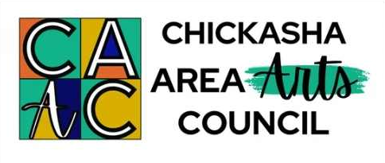

Arts Council Accepting Applications for Co-Directors & VA Instructors of ArtScope 2026
The Chickasha Area Arts Council (CAAC) has begun planning for its 28th annual ArtScope day camp and is accepting applications from individuals interested in being considered as a Co-Director or as a “Visual Arts” Instructor of ArtScope 2026. Deadline for submission of an application and up-to-date resume is Sun., Nov. 30, 2025.
ArtScope is a two-week multi-arts day camp for approximately 80 children, ages 8-12. The camp is June 1-12, 2026 from 9am-4pm on the USAO Campus in Chickasha, OK.
The “Co-Director” position involves coordinating and overseeing all aspects of ArtScope. It is a contracted and stipend-paid position with many responsibilities, including: CAAC membership; planning and working with camp staff; fundraising (including grant applications, seeking donations for camper scholarships, etc.); documenting all aspects of the program; writing and submitting final grant reports; receiving and organizing all camper applications and following up with required camper information; setting up for camp; completing an inventory and storing supplies and equipment after camp; communicating with parents/guardians of campers and the CAAC Board of Directors; promoting the camp in the community via several different media; selecting CITs (Counselors-in-Training) to assist with the camp; arranging for guest artists; and being involved in every facet of the camp for several months throughout the year.
“Visual Arts” instructors are to be members of the CAAC and attend all meetings of the ArtScope staff. This is a contracted position which has the following expectations: have training in Visual Arts; submit daily lesson plans based on the 2026 ArtScope camp theme and turn in a detailed supply list for the art projects by mid-March. Instructors are to be present on load-in day before ArtScope begins to assist in moving supplies to USAO and then set up their classrooms before students arrive for camp the following Monday. Each instructor is to be in the building at 8:30am during camp, be present every day for lunch duty, and clean classrooms daily. At the end of ArtScope, the instructors are to complete an evaluation of camp and an inventory of leftover supplies which will be moved and stored at the Chickasha Area Arts Council. Each instructor will have one or two CITs (Counselors-in-Training – teens who have been approved by the Co-Directors) who are assigned to assist teachers with daily classroom activities.
To obtain an application for ArtScope Co-Director or Instructor, visit the Arts Council’s website www.chickashaarts.org, email chickashaarts@gmail.com, or contact the CAAC office at 521 W. Chickasha Ave. and phone 405-448-5036.
In order to be considered for a Co-Director or “Visual Arts” Instructor position, a completed application and up-to-date resume must be received by the Arts Council by Sun., Nov. 30, 2025.
The CAAC’s mailing address is “ArtScope 2026, PO Box 505, Chickasha, OK 73023-0505”. The application may be brought to the CAAC’s office located at 521 W. Chickasha Avenue, Chickasha, OK or left in the outside CAAC drop box located between the two entrances.
The Chickasha Area Arts Council is a non-profit 501(c)3 all-volunteer organization governed by a Board of Directors. Activities and events of the CAAC are funded by memberships, individuals, businesses, clubs, and organizations. ArtScope is also supported by the Oklahoma Arts Council (OAC) and the National Endowment for the Arts (NEA).

