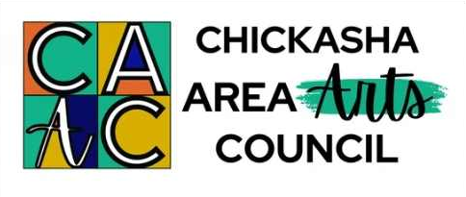
Chickasha Area Arts Council
Mailing Address – P.O. Box 505 – Chickasha, OK 73023
Physical Address – 521 W. Chickasha Avenue – Chickasha, OK 73018
www.chickashaarts.org 405-448-5036 chickashaarts@gmail.com
Federal Tax ID# 73-1385017

~ PRESS RELEASE ~

CAAC ‘Fine Arts’ Scholarship Applications – Due April 1, 2026

The Chickasha Area Arts Council (CAAC), a non-profit and all volunteer organization in Chickasha, OK, is pleased to offer High School Seniors an opportunity to apply this spring for college scholarships valued up to $1,000.

High School Seniors enrolled in public, private or home schools in the Chickasha area may apply for a ‘Gwen Brooks Memorial Arts Scholarship’, which was established by the CAAC in 2008.

Students wishing to apply must have been OR are actively involved in the ‘Fine Arts’ in their school AND/OR in the community. The ‘Fine Arts’ include: (1) Visual Arts (drawing, painting, pottery, sculpting, etc.) and (2) Performance Arts (dance, instrument, theatre, vocal).

Applicants may attend a college or university of their choice and must MAJOR in the ‘Fine Arts’ to be considered for the CAAC’s ‘Gwen Brooks Memorial Arts Scholarship’.

The completed application form, official transcript, two photos and/or recordings or video clips which illustrate the applicant’s Art Strengths and Interests, and two letters of recommendation from persons other than family must be received by the Chickasha Area Arts Council by the end of the day on WEDNESDAY, APRIL 1, 2026.

The application is available (1) from High School Senior Counselors and Advisors; (2) online at www.chickashaarts.org; or (3) emailed, mailed, or faxed by contacting susangearhart@gmail.com or calling 405-314-3307.

The completed application and supporting materials may be: (1) mailed to the CAAC at PO Box 505, Chickasha, OK 73023, (2) emailed to susangearhart@gmail.com or chickashaarts@gmail.com OR (3) left in a sealed envelope labeled ‘Brooks Scholarship Materials’ at the CAAC Area Arts Shop located at 521 W. Chickasha Ave., Chickasha, OK between Monday through Friday from 10:00am to 5:00pm.

Questions: Susan 405-314-3307 or email susangearhart@gmail.com.

